1) (2 pts) Chapter 2 Text Book Problem 23
23. Consider an ARQ algorithm running over a 40-km point-to-point
fiber link.
(a) Compute the one-way propagation delay for this link, assuming that the speed of light is 2×10⁸ m/s in the fiber.
(b) Suggest a suitable timeout value for the ARQ algorithm to use.
(c) Why might it still be possible for the ARQ algorithm to time out and retransmit a frame, given this timeout value?

2) (2 pts) Chapter 2 Text Book Problem 31
31. Draw a timeline diagram for the sliding window algorithm with SWS = RWS = 3 frames, for the following two situations. Use a timeout interval of about 2×RTT.
(a) Frame 4 is lost.
(b) Frames 4 to 6 are lost.

Hints/Help: Look at extra problem #32 for a timeline example. In this problem, assume that it takes ¼ RTT to transmit a frame. Use a timeout of 2 RTT.
a) When frames 5 and 6 are received no ack is sent. An ack is sent for frames 4,5 and 6 once the retransmitted frame 4 is received.
Something to keep in mind (but not part of this problem) is when a frame is received (but not 4), protocol could have the receiver send an ack for frame 3 again which indicates a frame received but not 4.

b) When frames 4-6 are sent, the transmitter needs to wait for an ack or for timeout before sending another frame.

3) (2 pts) Chapter 2 Text Book Problem 42 a,b(answer b to the best of your ability)

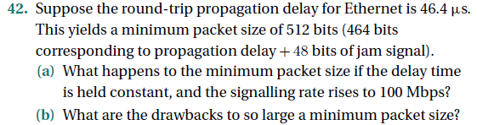

4) (2 pts) short answer problems:
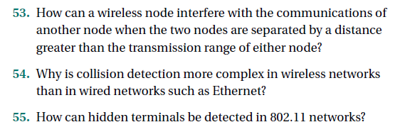

5) (2 pts) Chapter 3 Text Book Problem 1.

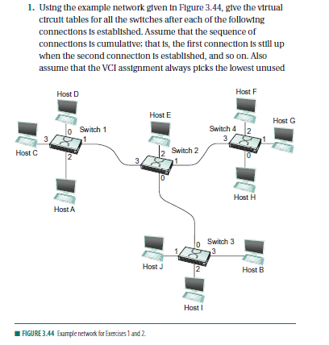
VCI on each link, starting with 0, and that a VCI is consumed
for both directions of a virtual circuit.
(a) Host A connects to host C.
(b) Host D connects to host B.
(c) Host D connects to host I.
(d) Host A connects to host B.
(e) Host F connects to host J.
(f ) Host H connects to host A.

